
Component Model
SLAM
Robotic Cognition System for Wheelchair
Unicamp

Table of Contents
1 Purpose of this Document 3
2 Component Design 4
2.1 Purpose 4
2.2 System Diagram 4
2.3 Component Input 4
2.4 Component Output 4
2.5 Component Processing 4
3 Component Execution 6
4 References 8

Document Information
Project Name: | Robotic Cognition System for Wheelchair
Prepared By: | Tarcísio Franco de Carvalho | Document Version No: | 1.0
Title: | Component Model – UPD Processing | Document Version Date:
Reviewed By: |  | Review Date:
Distribution List
From | Date | Email

Acronyms
Acronym | Description
UPD | Unevenness Point Data
ROS | Robot Operational System
AMCL | Adaptative Monte Carlo Localization

Document Version History
Version  Number | Version  Date | Revised By | Description | Filename

Purpose of this Document
Define how the related component works and its relation in the main system.

Component Design

Purpose
This component is responsible to execute the transversability analysis on the point cloud data captured by a depth-sensing camera as Microsoft Kinect. The transversability analysis produced by this component will be one of the inputs to classify the ground passage condition for a wheelchair.

System Diagram

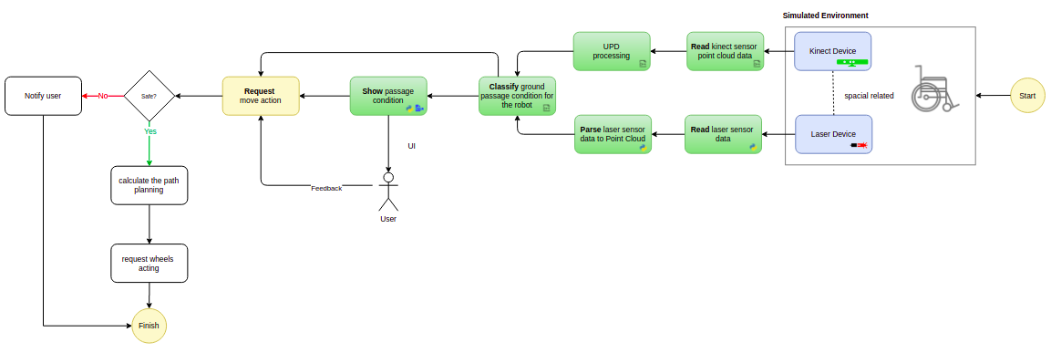

Component Input
This component reads the ROS node “/camera/depth/points” that publishes the depth-sensing data in Point Cloud format in a defined cycle. The point cloud data is stored in a variable to be processed.

Component Output
This component publishes the transversability analysis in point cloud data format in the ROS node “/upd_point_cloud_classification” in a defined cycle.

Component Processing
This component has relationship with the camera depth points ROS node, UPD library and a publisher ROS node to publish the output data. The diagram below shows this relationship:

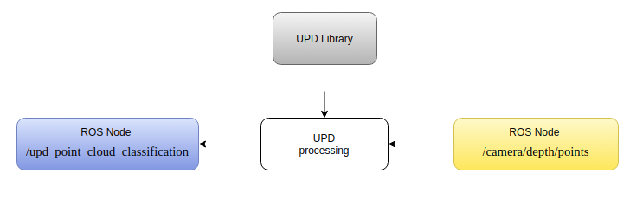

Below the main process flow for this component that occurs in cycles:

- Read laser scan from ROS nodelet camera depth image to laser scan parser
- Create the environment map continuously
- AMCL particle filter method to localize the Robotics
- Define the path planning to a target point
- Move to the target point
- Particle Filter to localize the robot

Component Execution

To execute this component is necessary the Gazebo simulation environment, ROS main process running and the Rviz tool to show processed data. Bellow the steps to run this component:

- Start Gazebo environment simulation
On the project root folder, run the script ./sim_model/scripts/launch.sh it will process the simple_blocks.world and sim_model.urdf.xacro files

Result
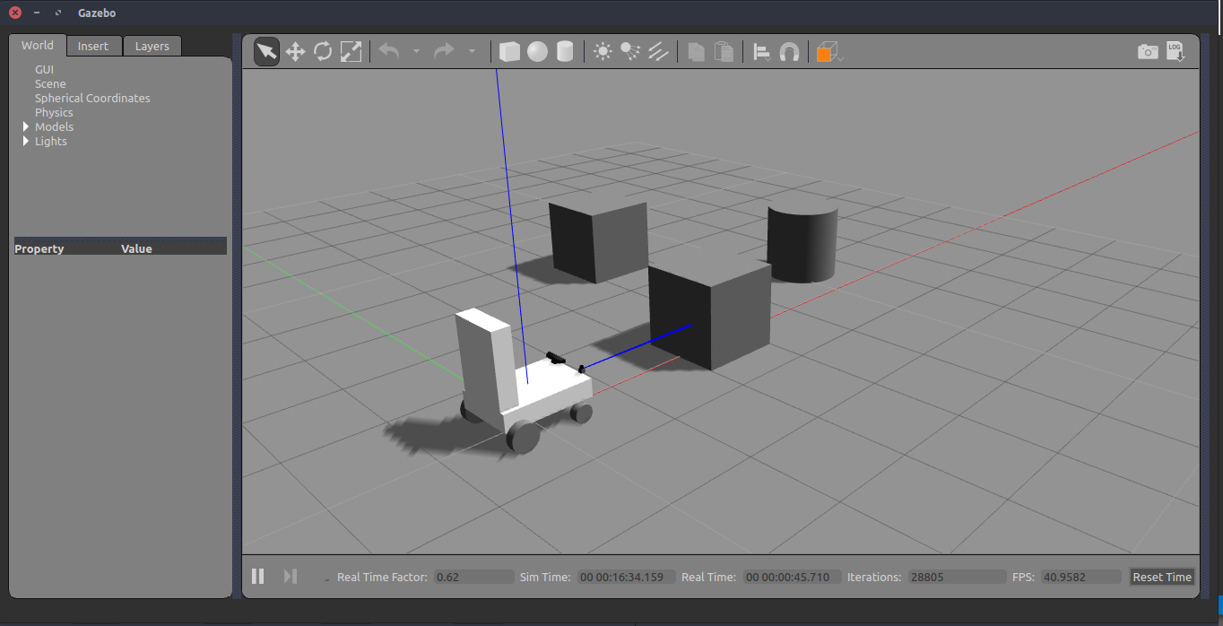

- Start the UPD processing component

On the project root folder, run the script ./upd_run.sh it will start a node to published UPD data

Result
In Rviz the UPD data is being showing.

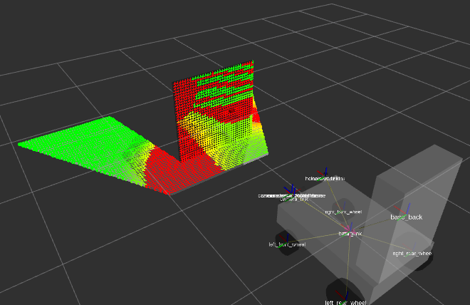

References

- FastSLAM 2.0 - http://robots.stanford.edu/papers/Montemerlo03a.html
- OpenSlam - https://openslam-org.github.io/gmapping.html
- ROS Gmapping - http://wiki.ros.org/gmapping
- ROS AMCL - http://wiki.ros.org/amcl
- Book - Learning Robotics using Python – Second Edition – By Lentin Joseph
- Open Transversability
  - UPD Home Page - http://www.maurobellone.com/robotics/upd_demo
  - UPD Git Hub - https://github.com/bellonemauro/OpenTraversability
- Point Cloud
  - Downsampling a PointCloud using a VoxelGrid filter - http://vml.sakura.ne.jp/koeda/PCL/tutorials/html/voxel_grid.html
  - Voxel - https://en.wikipedia.org/wiki/Voxel
  - Estimate the transformation matrix between two set of points (PCL): https://machinelearning1.wordpress.com/2014/02/09/estimate-the-transformation-matrix-between-two-sets-of-points-pcl/
- ROS
  - ROS and Gazebo for Depth Camera: http://gazebosim.org/tutorials/?tut=ros_depth_camera
  - Control: http://wiki.ros.org/ros_control
  - ROS and Gazebo Tutorial: http://wiki.ros.org/action/fullsearch/urdf/Tutorials/Using%20a%20URDF%20in%20Gazebo?action=fullsearch&context=180&value=linkto%3A%22urdf%2FTutorials%2FUsing+a+URDF+in+Gazebo%22
- Others
  - Rotation Matrix: https://en.wikipedia.org/wiki/Rotation_matrix
  - Rotating project point: http://www.pcl-users.org/Rotating-projected-point-cloud-to-get-z-0-for-all-points-td4034031i20.html
  - C++ Eigen Matrix: https://eigen.tuxfamily.org/dox/group__TutorialMatrixClass.html

